1.

using System;

using System.Collections.Generic; using System.Linq;

using System.Text;

namespace criteria

{

class Program

{

static void Main(string[] args)

{

int math; int phy; int chem; int tot;

Console.WriteLine("Name : Uday Sheth"); Console.WriteLine("Enrollment number : 210801320"); Console.WriteLine("Enter three subject marks :"); math = Convert.ToInt32(Console.ReadLine());

phy = Convert.ToInt32(Console.ReadLine()); chem = Convert.ToInt32(Console.ReadLine()); tot = math + phy + chem;

if (math >= 65 && phy >= 55 && chem >= 50 && tot >= 180)

{

}

else

{

}

}

}

}

Console.WriteLine("Input the marks obtained in Mathematicss :" + math); Console.WriteLine("Input the marks obtained in Physics :" + phy); Console.WriteLine("Input the marks obtained in Chemistry :" + chem); Console.WriteLine("Total in all three subject :" + tot); Console.WriteLine("The candidate is eligible for admission.");

Console.WriteLine("The candidate is not eligible for admission.");

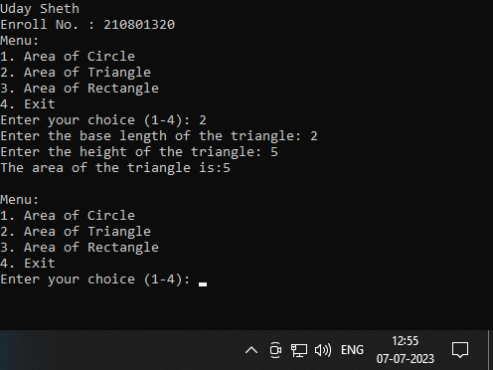Output :

# 2.

using System;

using System.Collections.Generic; using System.Linq;

using System.Text;

namespace temperature

{

class Program

{

static void Main(string[] args)

{

Console.WriteLine("Name : Uday Sheth"); Console.WriteLine("Enroll no. : 210801320"); int temp;

Console.WriteLine("Enter temperature : "); temp = Convert.ToInt32(Console.ReadLine()); if (temp < 0)

{

Console.WriteLine("Freezing weather");

}

else if (temp < 10)

{

Console.WriteLine("Very Cold weather");

}

else if (temp >= 10 && temp <= 20)

{

Console.WriteLine("Cold weather");

}

else if (temp >= 20 && temp <= 30)

{

Console.WriteLine("Normal weather");

}

else if (temp >= 30 && temp <= 40)

{

Console.WriteLine("Hot weather");

}

else if (temp >= 40)

{

Console.WriteLine("Very hot weather");

}

}

}

}

Output :

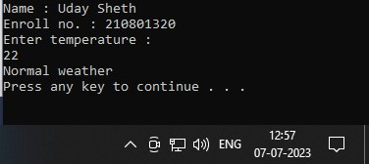

# 3.

using System;

using System.Collections.Generic; using System.Linq;

using System.Text;

namespace ConsoleApplication1

{

class Program

{

static void Main(string[] args)

{

Console.WriteLine("Uday Sheth"); Console.WriteLine("Enroll No. : 210801320");

int choice; do

{

Console.WriteLine("Menu:"); Console.WriteLine("1. Area of Circle"); Console.WriteLine("2. Area of Triangle"); Console.WriteLine("3. Area of Rectangle"); Console.WriteLine("4. Exit"); Console.Write("Enter your choice (1-4): "); choice = Convert.ToInt32(Console.ReadLine());

switch (choice)

{

case 1:

CalculateCircleArea(); break;

case 2:

CalculateTriangleArea(); break;

case 3:

CalculateRectangleArea(); break;

case 4:

Console.WriteLine("Exiting the program..."); break;

default:

Console.WriteLine("Invalid choice! Please enter a valid option."); break;

}

Console.WriteLine();

} while (choice != 4);

}

static void CalculateCircleArea()

{

Console.Write("Enter the radius of the circle: "); double radius = Convert.ToDouble(Console.ReadLine());

double area = Math.PI * radius * radius;

Console.WriteLine("The area of the circle is: " + area);

}

static void CalculateTriangleArea()

{

Console.Write("Enter the base length of the triangle: "); double baseLength = Convert.ToDouble(Console.ReadLine());

Console.Write("Enter the height of the triangle: "); double height = Convert.ToDouble(Console.ReadLine());

double area = 0.5 * baseLength * height;

Console.WriteLine("The area of the triangle is:" + area);

}

static void CalculateRectangleArea()

{

Console.Write("Enter the length of the rectangle: "); double length = Convert.ToDouble(Console.ReadLine());

Console.Write("Enter the width of the rectangle: "); double width = Convert.ToDouble(Console.ReadLine());

double area = length * width;

}

}

}

Output :

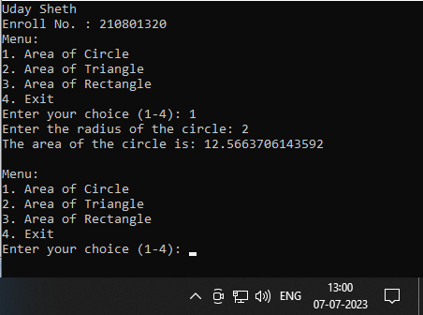

# 4 .

using System;

using System.Collections.Generic; using System.Linq;

using System.Text; class Program

{

static void Main(string[] args)

{

Console.WriteLine("Name : Uday Sheth"); Console.WriteLine("Enroll no : 210801320"); int choice;

do

{

Console.WriteLine("Menu:"); Console.WriteLine("1. Palindrome number"); Console.WriteLine("2. Armstrong number");

Console.WriteLine("3. Convert Centigrade to Fahrenheit"); Console.WriteLine("4. Convert kilometers per hour to miles per hour"); Console.WriteLine("5. Exit");

Console.Write("Enter your choice (1-5): "); choice = Convert.ToInt32(Console.ReadLine());

switch (choice)

{

case 1:

CheckPalindrome(); break;

case 2:

CheckArmstrong(); break;

case 3:

ConvertCentigradeToFahrenheit(); break;

case 4:

ConvertKilometersToMiles(); break;

case 5:

Console.WriteLine("Exiting the program..."); break;

default:

Console.WriteLine("Invalid choice! Please enter a valid option."); break;

}

Console.WriteLine();

} while (choice != 5);

}

static void CheckPalindrome()

{

Console.Write("Enter a number: ");

int number = Convert.ToInt32(Console.ReadLine());

int originalNumber = number; int reverse = 0;

while (number != 0)

{

int remainder = number % 10; reverse = reverse * 10 + remainder; number /= 10;

}

if (originalNumber == reverse)

{

Console.WriteLine("The number is a palindrome.");

}

else

{

Console.WriteLine("The number is not a palindrome.");

}

}

static void CheckArmstrong()

{

Console.Write("Enter a number: ");

int number = Convert.ToInt32(Console.ReadLine());

int originalNumber = number; int result = 0;

int digits = GetNumberOfDigits(number);

while (number != 0)

{

int remainder = number % 10;

result += (int)Math.Pow(remainder, digits); number /= 10;

}

if (originalNumber == result)

{

Console.WriteLine("The number is an Armstrong number.");

}

else

{

Console.WriteLine("The number is not an Armstrong number.");

}

}

static int GetNumberOfDigits(int number)

{

int count = 0; while (number != 0)

{

number /= 10; count++;

}

return count;

}

static void ConvertCentigradeToFahrenheit()

{

Console.Write("Enter the temperature in Centigrade: "); double centigrade = Convert.ToDouble(Console.ReadLine());

double fahrenheit = (centigrade * 9 / 5) + 32;

Console.WriteLine("The temperature in Fahrenheit is: " + fahrenheit);

}

static void ConvertKilometersToMiles()

{

Console.Write("Enter the speed in kilometers per hour: "); double kilometersPerHour = Convert.ToDouble(Console.ReadLine());

double milesPerHour = kilometersPerHour / 1.60934;

Console.WriteLine("The speed in miles per hour is: " + milesPerHour);

}

}

Output :

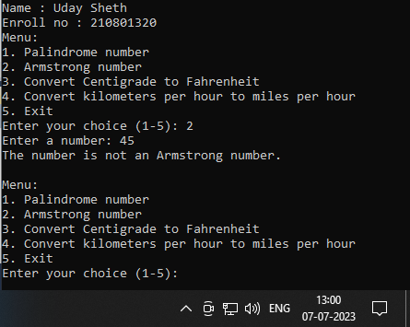

# 5.

using System;

using System.Collections.Generic; using System.Linq;

using System.Text;

namespace ConsoleApplication3

{

class Program

{

static void Main(string[] args)

{

Console.WriteLine("Name : Sheth Uday");

Console.WriteLine("Enroll no : 210801320");int choice; do

{

Console.WriteLine("Menu:"); Console.WriteLine("1. Calculate total minutes");

Console.WriteLine("2. Convert minutes to hours and minutes"); Console.WriteLine("3. Find the second largest number"); Console.WriteLine("4. Exit");

Console.Write("Enter your choice (1-4): "); choice = Convert.ToInt32(Console.ReadLine());

switch (choice)

{

case 1:

CalculateTotalMinutes(); break;

case 2:

ConvertMinutesToHoursAndMinutes(); break;

case 3:

FindSecondLargestNumber(); break;

case 4:

Console.WriteLine("Exiting the program..."); break;

default:

Console.WriteLine("Invalid choice! Please enter a valid option."); break;

}

Console.WriteLine();

} while (choice != 4);

}

static void CalculateTotalMinutes()

{

Console.Write("Enter the number of hours: "); int hours = Convert.ToInt32(Console.ReadLine());

Console.Write("Enter the number of minutes: "); int minutes = Convert.ToInt32(Console.ReadLine());

int totalMinutes = (hours * 60) + minutes;

Console.WriteLine("The total number of minutes is: " + totalMinutes);

}

static void ConvertMinutesToHoursAndMinutes()

{

Console.Write("Enter the number of minutes: "); int minutes = Convert.ToInt32(Console.ReadLine());

int hours = minutes / 60;

int remainingMinutes = minutes % 60;

Console.WriteLine("The total number of hours is: " + hours); Console.WriteLine("The total number of minutes is: " + remainingMinutes);

}

static void FindSecondLargestNumber()

{

Console.Write("Enter the first number: ");

int number1 = Convert.ToInt32(Console.ReadLine());

Console.Write("Enter the second number: ");

int number2 = Convert.ToInt32(Console.ReadLine()); Console.Write("Enter the third number: ");

int number3 = Convert.ToInt32(Console.ReadLine());

int secondLargestNumber = Math.Max(Math.Min(number1, number2), Math.Min(Math.Max(number1, number2), number3));

Console.WriteLine("The second largest number is: " + secondLargestNumber);

}

}

}

# Output :

